School Year 2019-20 Sports Registration Packet Directions

Dear Baltimore City College Athletes and Families:

I would like to extend a warm welcome to all new and returning Knights for the 2019-2020 school year!
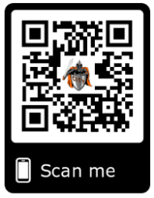
We are excited to announce that we now offer the convenience of online registration for our sports programs through the registration platform, Form^{Re}Leaf! Form^{Re}Leaf is an intuitive and secure registration platform providing you with a user-friendly way to register for our programs, while helping us to be more administratively efficient.

BEGIN YOUR ONLINE REGISTRATION using this link to Form^{Re}Leaf:

https://app.formreleaf.com/organizations/baltimore-city-college-high-school

- Signup for your Form^{Re}Leaf account by entering your name, e-mail address and password; confirm your password. Agree to the FormReleaf Terms of Service.
- Now login to Form^{Re}Leaf using your credentials (email address and password)
- On the top menu bar select “Find Organization”
- Search for Baltimore City College by typing the first few letters of our school’s name; once located, click on “Baltimore City College”.
- Click on the Program (“Fall Athletics”) you wish to register for.
- After clicking on the appropriate Sport(s), complete all of required information.
- Sign (using your mouse/finger/stylus) in those fields where appropriate.
- When finished click “Submit”
- You will receive confirmation from Form^{Re}Leaf when you have completed your registration.
- The Athletic Office will verify all registrations once submitted.
- If you need help at any point of the registration process, you may call Form^{Re}Leaf Customer Support, Monday through Saturday at (844) 367-6735.

The Athletics Staff of Baltimore City College are excited about this extremely intuitive registration platform and hope that you will appreciate and enjoy the ease of registering your students for our athletic programs going forward.

Go Knights!

Rolynda Contee
Director of Athletics,
Baltimore City College
443-642-6523
RAContee@bcps.k12.md.us

